7. Domain Model
The domain model shows the real-world concepts in the problem, their attributes and how they relate. It is the starting point for the database schema and the class design.
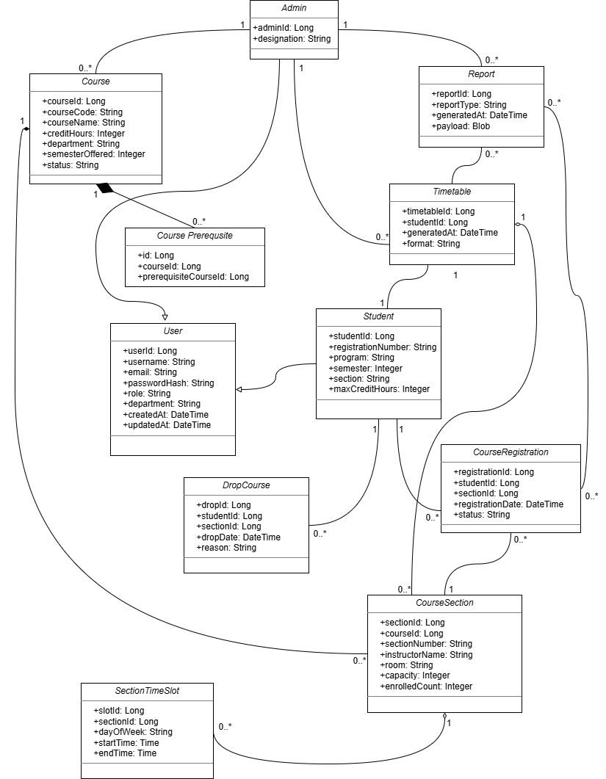
Figure 12: Domain Model for the Course Registration and Timetable Scheduler

7.1 Domain Concepts and Data Dictionary
Table 24: Domain concepts and data dictionary
Concept | Key attributes | Description and constraints
User | userId, username, email, passwordHash, role, department, createdAt, updatedAt | Generalisation of Student and Admin. Username and email are unique; role is Student or Admin; only the hash of the password is stored.
Student | studentId, registrationNumber, program, semester, section, maxCreditHours | Specialisation of User. Registration number is unique (A-2). maxCreditHours is the credit limit used by BR-1.
Admin | adminId, designation | Specialisation of User. Manages courses, generates timetables and reports.
Course | courseId, courseCode, courseName, creditHours, department, semesterOffered, status | Course code is unique (BR-5). Status is Active or Archived.
CoursePrerequisite | id, courseId, prerequisiteCourseId | A course may have 0..* prerequisites; deleted with the course.
CourseSection | sectionId, courseId, sectionNumber, instructorName, room, capacity, enrolledCount | A section of a course. 0 ≤ enrolledCount ≤ capacity (BR-6).
SectionTimeSlot | slotId, sectionId, dayOfWeek, startTime, endTime | Weekly meeting of a section. startTime < endTime; used for clash detection.
CourseRegistration | registrationId, studentId, sectionId, registrationDate, status | A student's enrolment in a section. At most one active registration per student and course (BR-8).
DropCourse | dropId, studentId, sectionId, dropDate, reason | History record of a dropped registration (FR-27).
Timetable | timetableId, studentId, generatedAt, format | Weekly schedule generated for one student (FR-29).
Report | reportId, reportType, generatedAt, payload | Report produced by an administrator (FR-34).

